CS-114 - Fundamental of Programing

Lab# 6

**Course Instructor:** Dr Khwaja Fahad Iqbal

**Lab Instructor:** Muhammad Affan

## Student Name: Muhammad Hanzla Masood

**CMS ID: 463722**

**Task 1:**

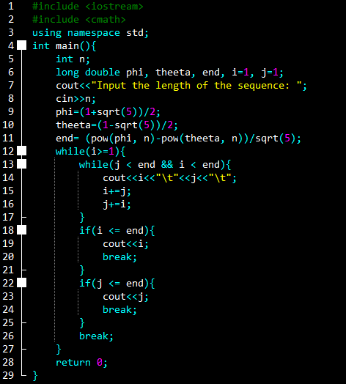

**Task 1 Output:**

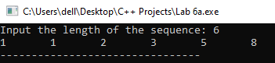

**Task 2:**

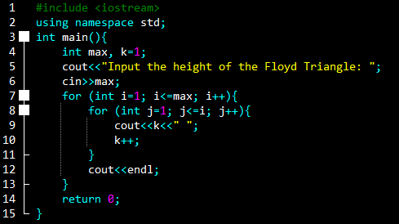

**Task 2 Output:**

